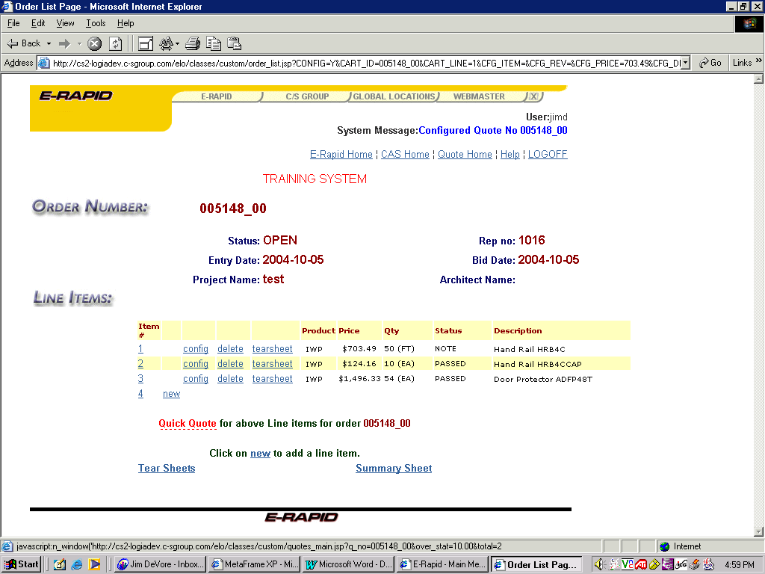
LINE ITEM QUOTING

Once the quotation is complete, click on Quick Quote.

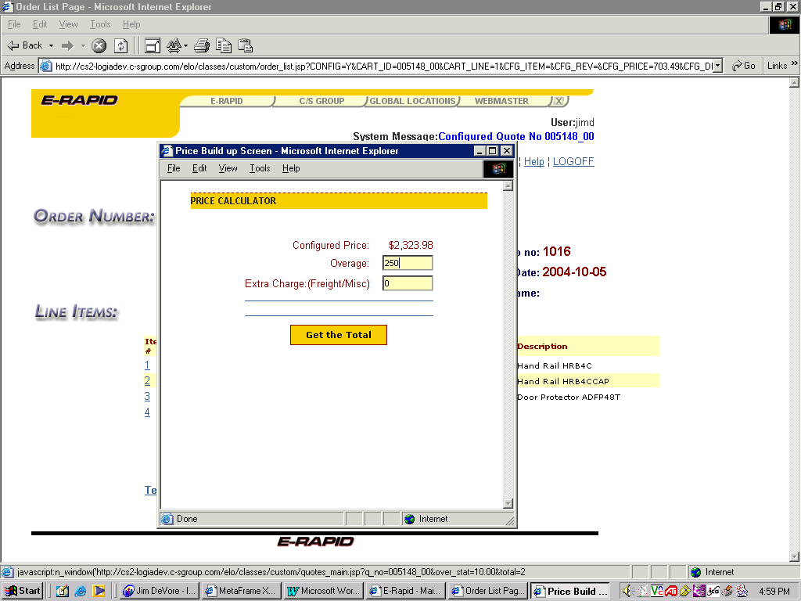
As always, the Price Calculator screen appears where overage can be added, as well as special freight. In addition, handling and small order charges are assessed here.

Once prepared, click on “Get the Total”.

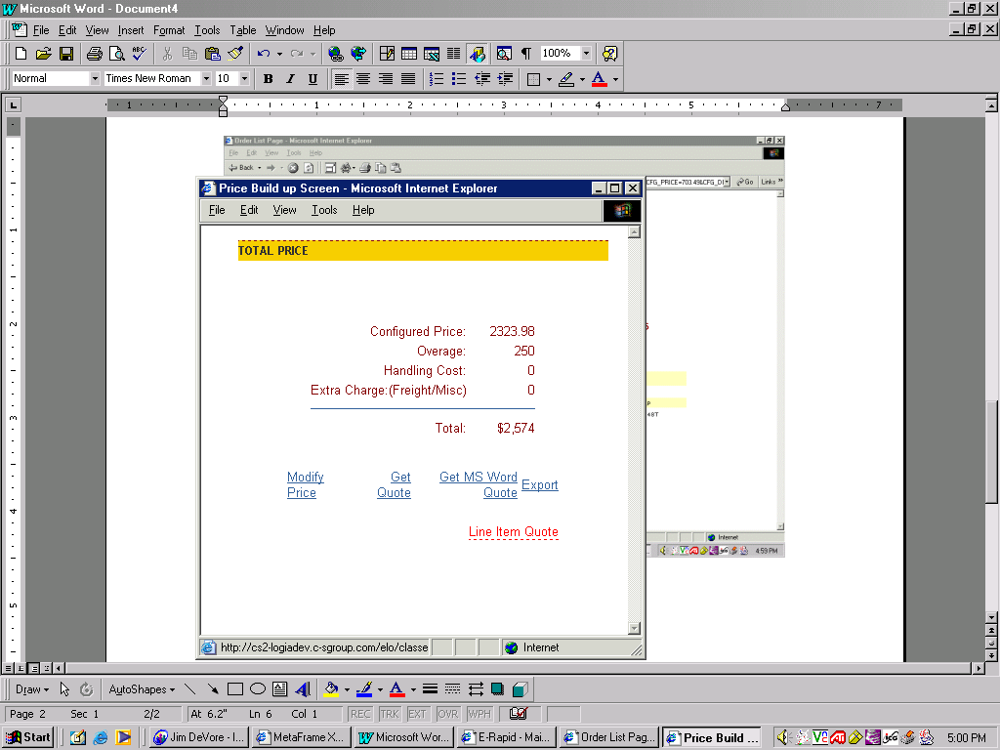

The same recap screen appears with one exception – a new “Line Item Quote” link. By selecting this option, you will be able to automatically generate a line item quotation (see next page for results).

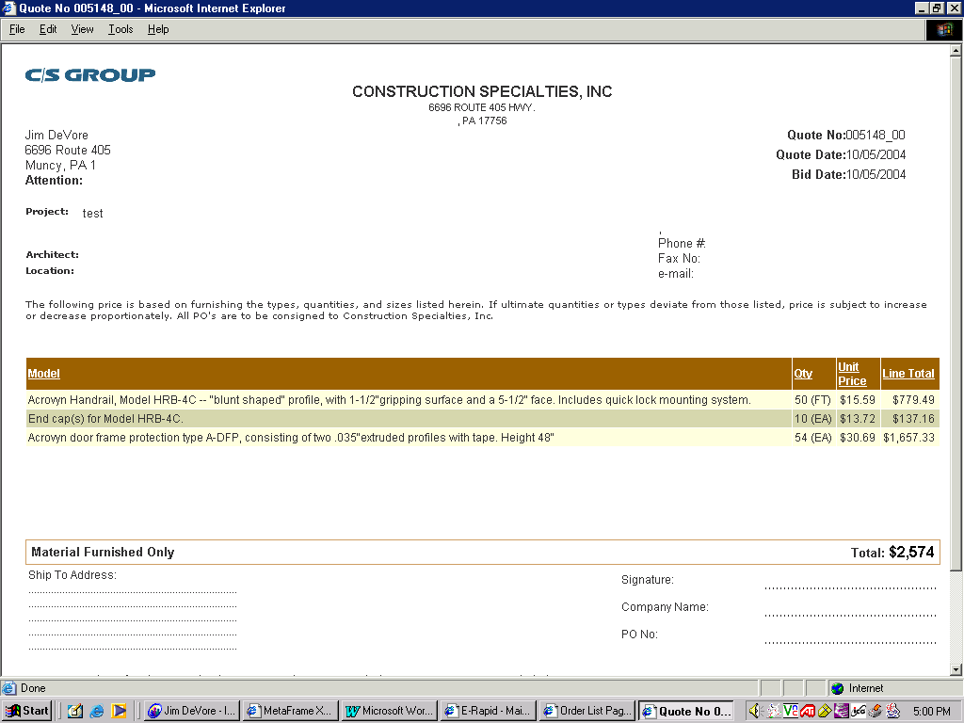

This is the end result. Notice that overage is adjusted automatically throughout the quotation.

NOTE: Handling and special charges are shown as separate line items.

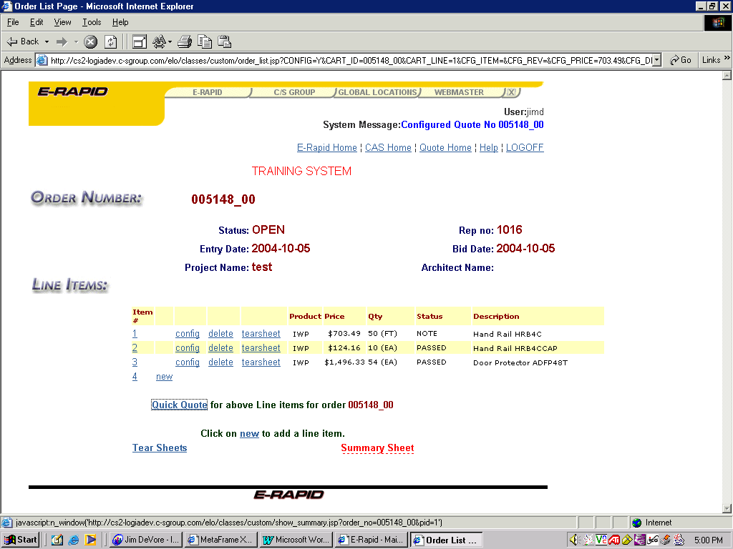

There is additional information on the “Summary Sheet” link that assists in the breakout values of the overage applied.

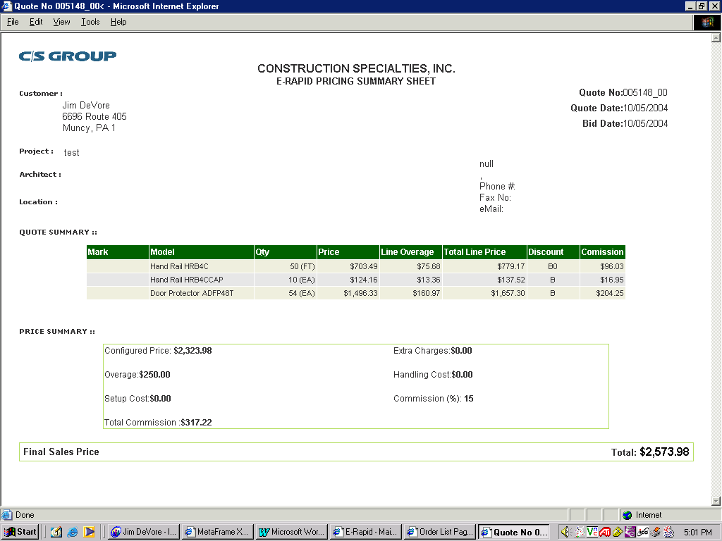

This is the revised summary sheet, which explains the split on line overages for the new quoting functionality.

